Lab Report

Your Information
Your Name: Joshua Zimmerman-Gibson
Assignment Title: Power BI Dashboard Creation

Screenshots
- Load the Tabular Online Shopper Dataset Download Tabular Online Shopper Datasetinto Power BI. Create relationships between the following tables:
  - OnlineShopperData and OperatingSystems using the OID and OSID keys
  - OnlineShopperData and Browsers using the BID key
  - OnlineShopperData and Regions using the RID key
  - OnlineShopperData and TrafficTypes using the TID key
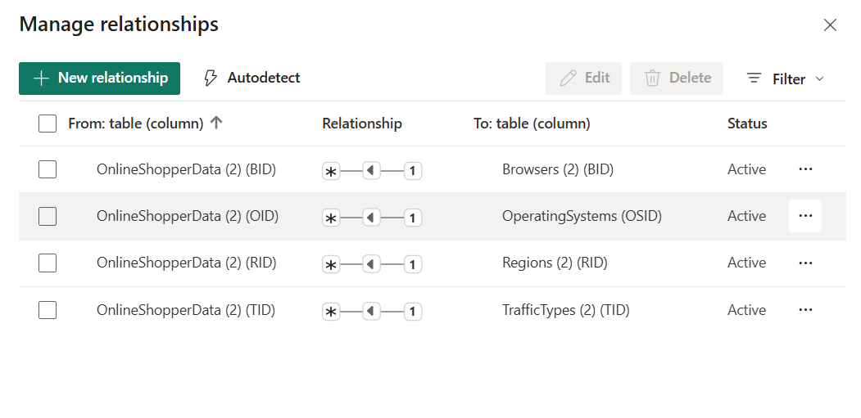
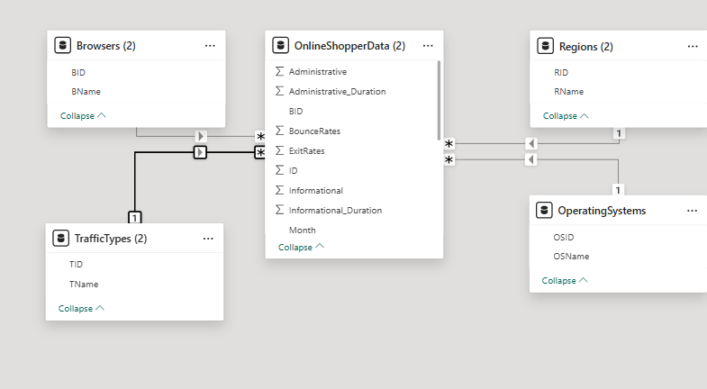
- Add a column containing your studentID and a column containing the current date to the OnlineShopperData table.
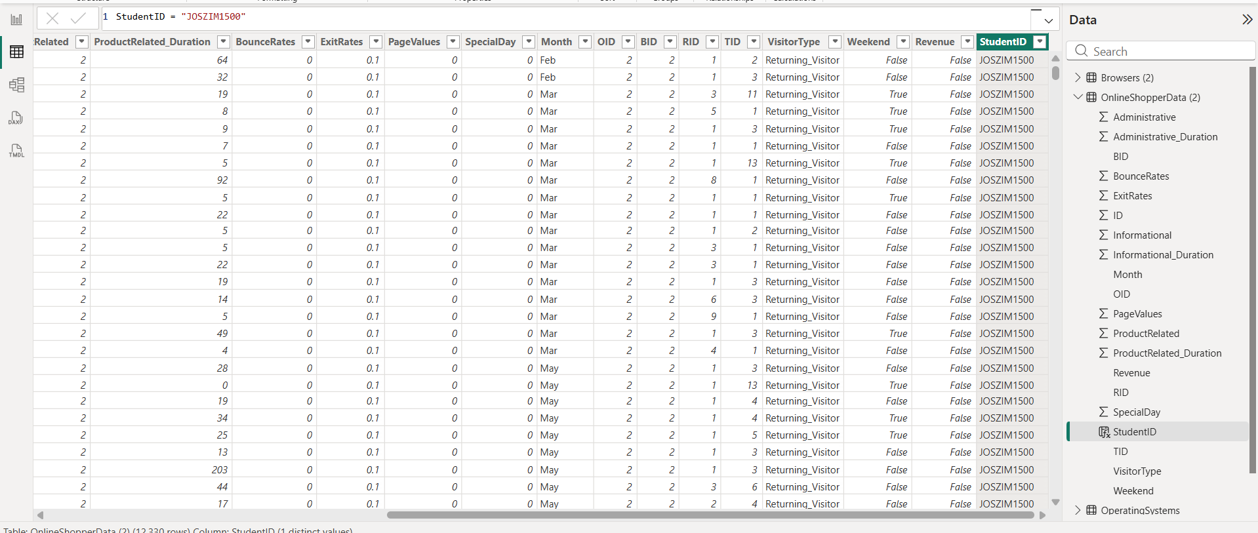
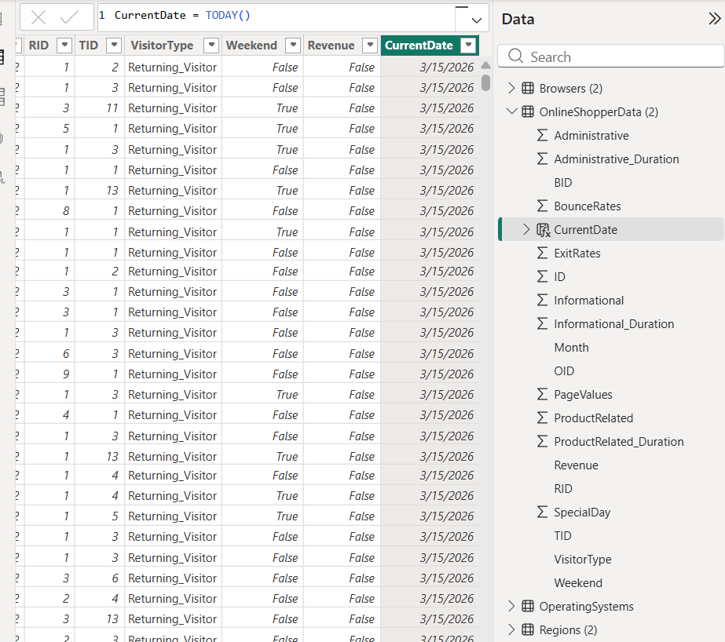
- Add a column to the OperatingSystems table showing the total visitor count per operating system. Add a similar column in the Browsers table showing the total visitor count per browser.
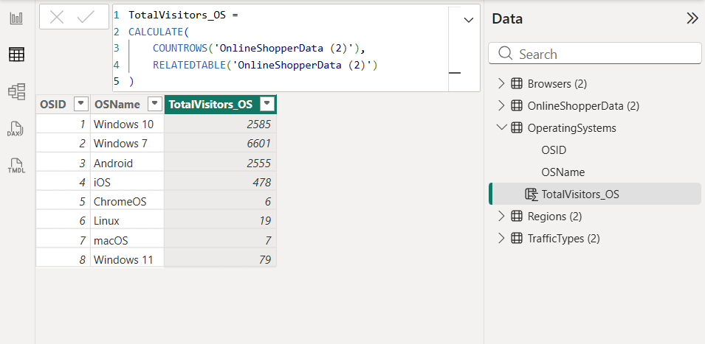
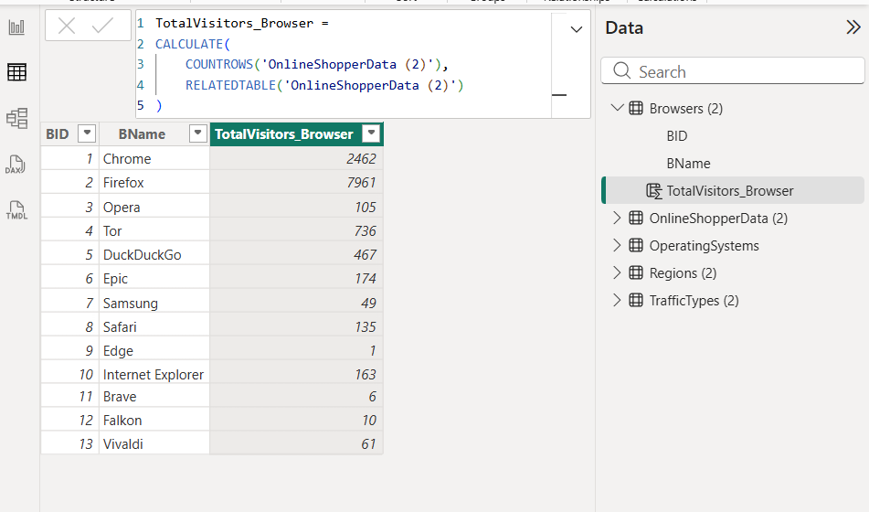

- Add a column to the Regions table showing the average bounce rate per region. Add a similar column to the TrafficTypes table showing the average bounce rate per traffic type.
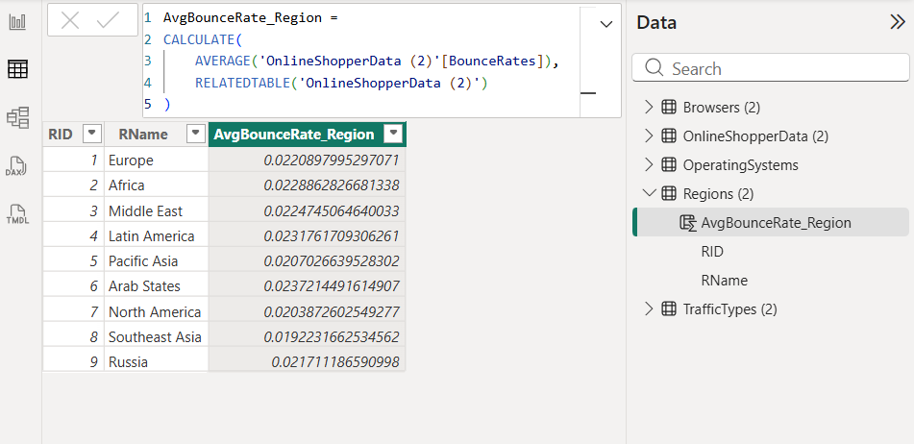
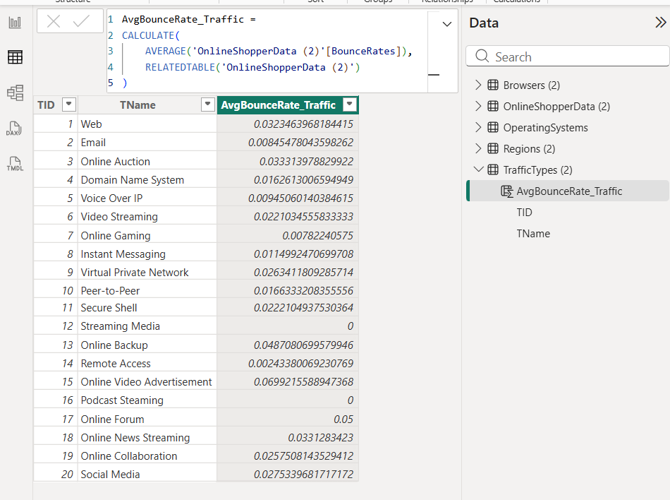
- Create the following graphs. Include your studentID and the current date in the title of each graph. Arrange the graphs so that each is easily visible on the dashboard.
  - Create a line graph showing the sum of ProductRelated over each month.
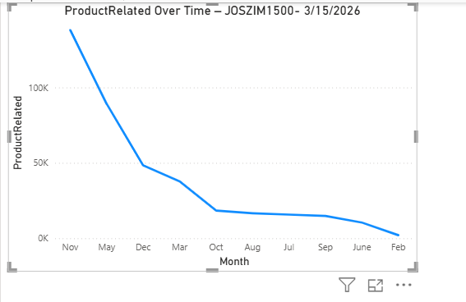
  - Create a bar graph showing the total Administration_Duration over each month.
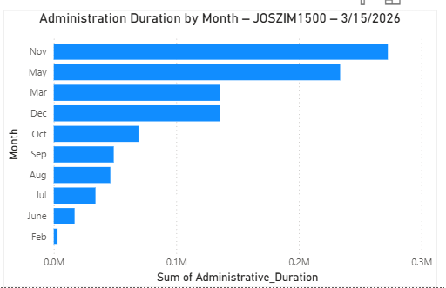
  - Create a bar graph that utilizes the SUM function to determine the sum of PageValue by VisitorType.
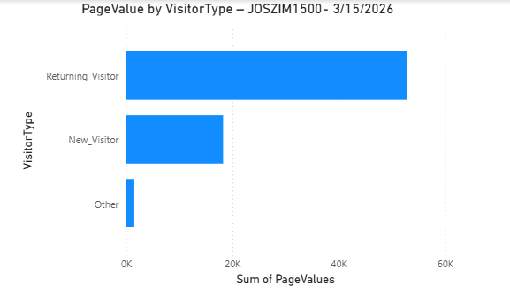
  - Create a pie chart displaying the count of VisitorType where Revenue was obtained.
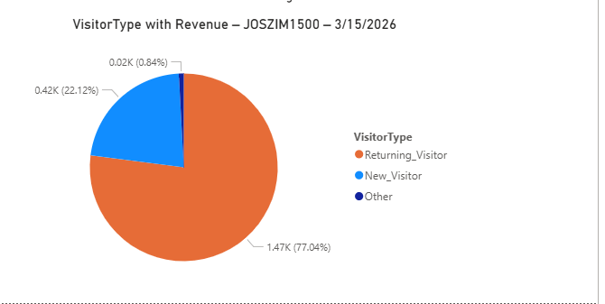

Questions
- What are the key differences between calculated columns and measures in Power BI, and when should each be used?
Calculated Columns
- Computed row-by-row during data model load or refresh.
- Stored in the data model, meaning they consume memory.
- Their values do not change based on filters or slicers (static after creation).
- Useful when you need:
  - A value used in relationships
  - A value displayed in rows or columns of a table visual
  - A value that must exist before aggregation
Examples
- Categorizing age groups
- Concatenating first and last names
- Flags like IsWeekend or HighBounceRate
Measures
- Calculated on the fly based on user interaction.
- Do not consume data model memory (stored as formulas, not values).
- Their values react dynamically to filters, slicers, and visuals.
- Ideal for:
  - Aggregations (SUM, AVERAGE, COUNT, etc.)
  - KPIs
  - Context-dependent calculations
Examples
- Total Revenue
- Average Bounce Rate per selected region
- Conversion rate depending on applied filters

- What are some approaches to optimizing DAX calculations for performance in large datasets?
1. Use Measures Instead of Calculated Columns
Measures compute only when needed and don't bloat the model.
2. Reduce Cardinality
High-cardinality columns slow down calculation and storage.
- Split DateTime into Date and Time
- Round decimals
- Remove unnecessary precision
3. Avoid Row-by-Row Functions When Possible
Functions like EARLIER, ROW, or complex row context transitions slow performance. Prefer vectorized functions such as:
- SUMX
- AVERAGEX
- CALCULATE
4. Push Logic to Query Editor (Power Query)
Let the M-language engine handle heavy transformations BEFORE loading to the model.

- What other DAX functions would be useful for gathering information about this particular data set? Briefly explain what columns and calculations would be utilized in the example functions.

CALCULATE() — Modify Filter Context

Useful for analyzing metrics under specific conditions.
B. SUMX() — Row-by-row Aggregations
Useful for metrics like total time spent or weighted averages.
C. AVERAGEX() — Weighted Metrics
Good for bounce rate analysis.
D. DISTINCTCOUNT() — Unique Visitor Analysis
Useful for understanding unique behavior patterns.
E. RELATED() — Pulling Data from Lookup Tables
Helps enrich OnlineShopperData using the relationships you created.
F. SWITCH() — Cleaner Conditional Logic
Useful for categorizing visitor types.

